|  |
| --- |
|  |
| Start Judgment_Project Explanation Materials |
| POC Cat KIT |

|  |
| --- |
| 株式会社 KPMG Ignition Tokyo  August 2023 |
| This report contains 10 pages |
|  |
| POC Cat KIT Start Decision Plan Template .docx |

© KPMG AZSA LLC, a limited liability audit corporation incorporated under the Japanese Certified Public Accountants Law and a member firm of the KPMG global organization of independent member firms affiliated with KPMG International Limited, a private English company limited by guarantee. All rights reserved.

**Document classification: KPMG Confidential**

Document review and approval

Revision history

|  |  |  |  |
| --- | --- | --- | --- |
| Version | Author | Date | Revision |
| 1.0 | Ken Izumi | 2023/08/03 | first edition |
|  |  |  |  |
|  |  |  |  |
|  |  |  |  |
|  |  |  |  |

This document has been reviewed by

|  |  |  |
| --- | --- | --- |
|  | Reviewer | Date reviewed |
|  | Naoko Iwamoto | 2023/08/03 |
|  |  |  |
|  |  |  |
|  |  |  |
|  |  |  |

This document has been approved by

|  |  |  |  |
| --- | --- | --- | --- |
|  | Subject matter experts | |  |
|  | Name | Signature | Date reviewed |
|  | Tsuyoshi Moriya |  | 2023/08/04 |
|  |  |  |  |
|  |  |  |  |
|  |  |  |  |
|  |  |  |  |

Contents

1 Outline of the project 1

1.1 Background & Purpose [ST1] 1

1.2 Service User [ST1] 1

1.3 Structure [ST1] 1

1.4 schedule 1

1.4.1 Hope for a period [ST1] 1

1.4.2 Deployment Schedule [ST2] 1

2 Technology Overview 2

2.1 Technology & Functional Overview [ST2] 2

2.2 System Overview Diagram [ST2] 2

2.3 Hosting Environment [ST2] 2

3 Type of information 3

3.1 Information - System Confidentiality, Integrity, and Availability [ST1] 3

3.1.1 Confidentiality of information 3

3.1.2 Completeness of information 3

3.1.3 System Availability 4

4 security 6

4.1 Permissions [ST2] 6

4.2 Encryption [ST2] 6

4.3 Network Isolation [ST2] 6

4.4 Logging Monitoring [ST2] 6

4.5 Redundancy and backup [ST2] 6

5 Software Development Approach 7

5.1 Documenting Frameworks and Processes [ST2] 7

5.2 Development Language [ST2] 7

6 Operation and Maintenance System 8

6.1 Corresponding department [ST1] 8

6.2 Security Incident System [ST2] 8

6.3 System Failure System [ST2] 8

6.4 System Operation and Maintenance System [ST2] 8

6.5 User Support System [ST2] 8

7 Test Preparation 9

7.1 UAT (User Acceptance Test) [ST2] 9

7.2 BCPテスト（Business Continuity Planning）　[ST2] 9

8 Release plan 10

8.1 Preparing for Release [ST2] 10

9 Establishment of OSS (Open Software) Management System 11

9.1 OSS Management Responsibilities and Response Policy [ST2] 11

10 approval 12

10.1 Service Owner Approval [ST1] 12

10.2 Budget Approval [ST1] 12

11 Security Assessment 13

11.1 Vendor Security Assessment Results [ST2] 13

11.2 Independence check [ST2] 13

11.3 Outsourcing of personal data processing [ST2] 13

11.4 Cloud Service Risk Assessment [ST2] 13

# Outline of the project

## Background and Purpose [ST1]

*(Describe the background and purpose)*

***Led by KIT's data scientists, we conducted research on generative AI. I would like to verify whether it can be used for KIT's internal operations. There is an issue that it takes time for KIT employees to grasp internal rules, and we will take it up as a use case to be verified.*** *​*

***Implementation period: September-October 2023***

***Purpose: To verify the feasibility and practicality of in-house use of generative AI technology. In addition, we will decide whether or not to proceed with commercial development for KIT use.***

***Scope:***

* ***Usage data: KIT-INTERNAL Some content in SharePoint,*** ***mainly attendance-related rules and instructions, such as work rules and how to take leave*** *(personal information is not included in the data used in this PoC)*
* ***利用技術：Azure Open AI Service、Azure Cognitive Search、One Platform Japan Country Hosting***

## Service User [ST1]

*(Describe the scope of service users (clients, KPMGJapan users, KPMG member firms, public users, etc.), the number of users, and the frequency of use.) ）*

*At the time of verification, the following is assumed*

|  |  |  |
| --- | --- | --- |
| user | Number of users | Frequency of use |
| KIT Project Members | About 5 people | About 20 hours per week |
| KIT User Test Participants | About 3-5 people | About 10 hours per week during 1-2 weeks during the project period |

## Structure [ST1]

|  |  |
| --- | --- |
| team | person in charge |
| KIT Project Members | Deleva, Giacomo (KIT)  Ahi, Sercan (KIT)  Izumi, Ken (KIT)  Bangari, Samuel (KIT)  Iwamoto, Naoko (KIT) |
| KIT User Test Participants | About 3-5 people will be assigned.  確定：Hashimoto, Mika (KIT) |

## schedule

### Desired delivery date [ST1]

*(Describe the desired delivery date and scheduled release date)*

*Desired delivery date: Subscription for CH verification should be provided by August 25thRelease date:*  
 *Not eligibleSubmit to a separate judgment meeting at the time of release after verification.*

### Deployment Schedule [ST2]

*(Outline schedule of introduction is described)*

***This time, it is for verification purposes, and there is no production release. If you want to apply it in production, apply for a start gate separately.***

***Verification period: September to October 2023***

# Technology Overview

## Technology & Feature Overview [ST2]

*(Provide an overview of the main technologies and functions used in system services)*

* **Azure Open AI Service** 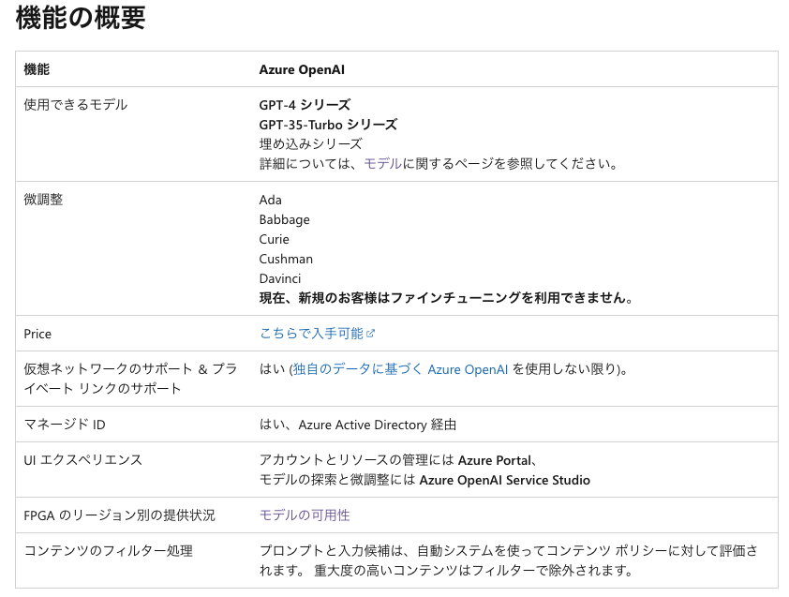

Source: [Azure OpenAI Service とは - Azure AI services | Microsoft Learn](https://learn.microsoft.com/ja-jp/azure/ai-services/openai/overview)

* **Azure Cognitive Search**

Azure Cognitive Search is a cloud search service that provides developers with the infrastructure, APIs, and tools to build rich search experiences for private, heterogeneous content into web, mobile, and enterprise applications.

Source: [Azure Cognitive Search の概要 - Azure Cognitive Search | Microsoft Learn](https://learn.microsoft.com/ja-jp/azure/search/search-what-is-azure-search)

## System Overview Diagram [ST2]

*(Describe the outline configuration diagram of the system)*

*Users & Data Flows*

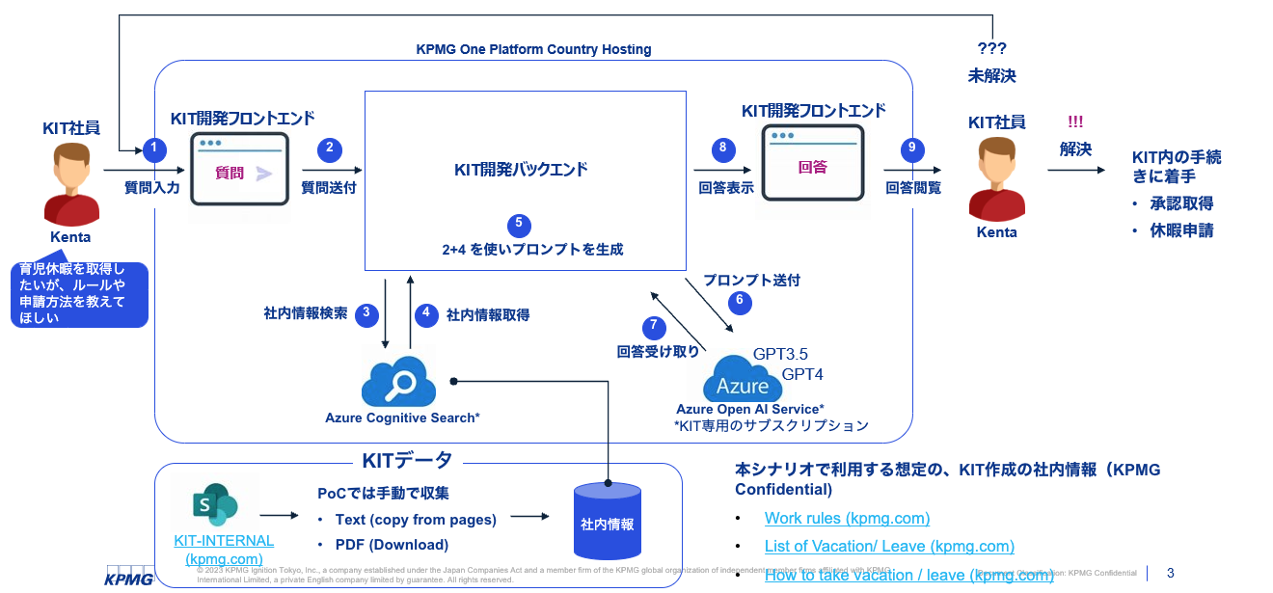

architecture

The following is the construction design on Cloud Next. Planned to be customized for CH

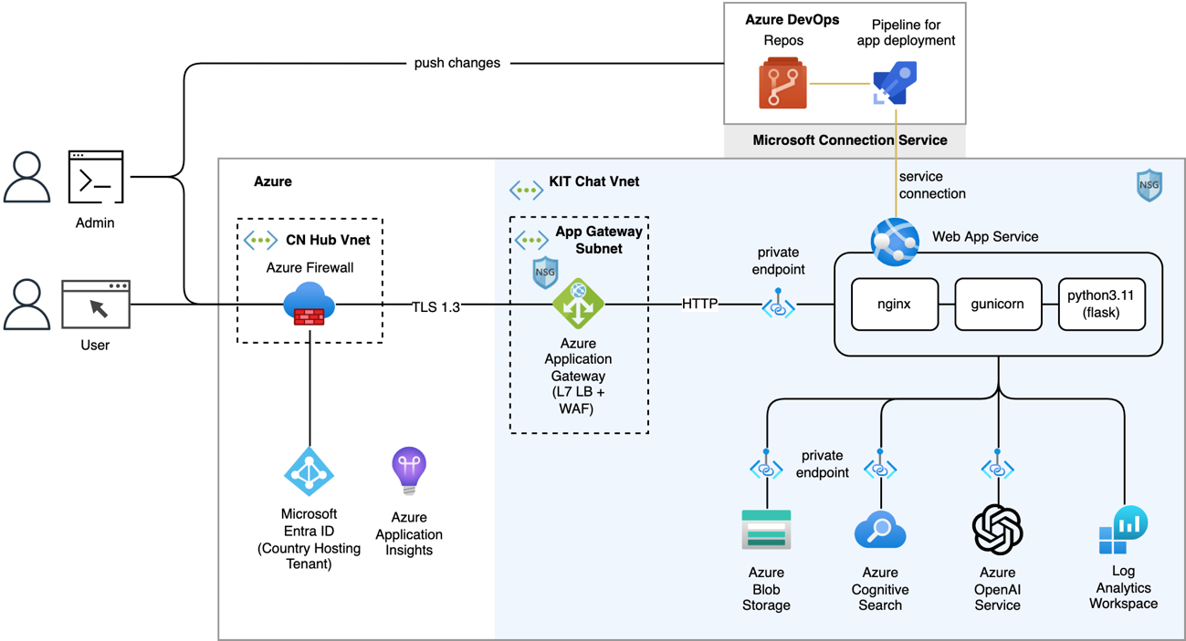

## Hosting Environment [ST2]

*(Describe the hosting environment of the system.) Public Cloud, One Platform, CloudNext, on-premise, etc. ）*

*One Platform (Country Hosting)上に構築する*

# Type of information

## information - System confidentiality, integrity, and availability [ST1]

*(Select the confidentiality, integrity, and availability of information and systems from the following definitions.) ）*

### Confidentiality of information

|  |  |  |  |
| --- | --- | --- | --- |
| Confidentiality of information | |  |  |
| Level of management  required | division | explanation |  |
| 4 | supreme | If information is leaked to unauthorized persons, it will have a serious impact on business, so it must not be disclosed or circulated to anyone other than the specific person involved in the information | **□** |
| 3 | high | If information is leaked to unauthorized persons, it will have a significant impact on business, so it must not be disclosed or circulated to anyone other than the specific person involved in the information | **□** |
| 2 | middle | If information is leaked to unauthorized persons, it will affect the business, so it can be disclosed and provided only to those involved in the business of the organization. | ☑ |
| 1 | low | Even if information is leaked to unauthorized persons, it can be disclosed and provided outside the company without affecting business operations. | **□** |
|  |  |  |  |

■ Presence or absence of personal information

|  |  |  |
| --- | --- | --- |
|  | Yes/No | detail |
| Presence or absence of personal information and My Number | possession | The personal data used includes user names, employee numbers, organizational affiliations, IIDs, and email accounts registered in Active Directory |
| Whether or not GDPR applies | nothing |  |
| Whether or not the client handles confidential data | nothing |  |

### Completeness of information

|  |  |  |  |
| --- | --- | --- | --- |
| Completeness of information | |  |  |
| Level of management  required | division | explanation |  |
| 3 | high | Even if the information is changed (tampered with, destroyed, etc.) without permission, if the content of the information is incorrect, or if all or part of the information is not available, the impact on business operations is serious and significant. | **□** |
| 2 | middle | Even if the information is changed (falsified, destroyed, etc.) without permission, if there is an error in the content of the information, or if all or part of the information is not available, the impact on business will be significant. | **□** |
| 1 | low | Even if the information is changed (falsified, destroyed, etc.) without permission, if the content of the information is incorrect, or if all or part of the information is not available, there will be little impact on business | ☑ |
|  |  |  |  |

### System Availability

■Business Criticalityレート

|  |  |
| --- | --- |
| **Business Criticality** |  |
| **BC4 – Mission Critical System**  A system that is critical to business execution, if it is not available even for a short period of time, it will have a significant impact on the business.  Recovery time is less than 4 hours;Always on. | **□** |
| **BC3 – Essential**  If the system is down for more than one day, it will have an impact on the business and the bottom line.  Recovery time is less than 24 hours;High availability. | **□** |
| **BC2 – Critical**  If the system goes down for a few days, you can lose a lot of revenue and reputation.  Recovery time is less than 7 days, standby facility (with or without expedited shipping contract). | **□** |
| **BC1 – Important**  If the system goes down for a few weeks, you can lose revenue.  The recovery period is no more than 2 months;Standby facility. | **□** |
| **BC0 – Low Impact**  If the system goes down for a few weeks, you can lose revenue.  Recovery time is less than 1 year | **☑** |

* Those set to BC3 or higher are subject to the BCP test. In that case, at the time of release judgment, it is necessary to switch to the DR site and prepare a cutback procedure manual, and to conduct a switch-back test even once, and to have a trail of it.

# security

## Permissions [ST2]

*(Describe the operation plan for access rights.) Administrators and users should have minimal access and comply with the Global Standard, and the start decision confirms that the operation of access rights is planned in the design phase. ）*

*Submit the required JP-SG application*

* *Groups containing JP-DL KIT-Employee*
* *Groups containing JP-DLKIT-Intern*

*Limited number of users at the time of verification*

## Encryption [ST2]

*(Describe the operation plan for encryption.) It is necessary to encrypt data at rest, data in transit, and communication data in accordance with the Global standard, and the start decision confirms that encryption is planned in the design phase. ）*

Communication is encrypted by TLS 1.2.

Access keys to Azure resources, including Azure Open AI, are protected by storing them in Key Vault.

Data at rest on Azure (Azure Storage, PostgreSQL) is encrypted with FIPS 140-2 certified cryptographic modules.

## Network Isolation [ST2]

*(Describe the plan for network isolation.) It is necessary to physically and logically separate the network according to the application (production, development, staging, etc.), and the start decision confirms that network isolation is planned in the design phase. ）*

The resource to be created uses Private Endpoint and blocks access from outside the company (= Internet). Users of the internal network access the application through ExpressRoute.

Specific VNet and NSG configurations are set in consultation with the ITS team at the time of subscription configuration.

## Logging Monitoring [ST2]

*(Audit log acquisition and monitoring are described.) The start decision confirms that logging and monitoring will be planned in the design phase. ）*

Application logs, Activity Logs (Azure Platform logs), various metrics, and OpenAI's output data required for quality improvement analysis are also maintained.

## Redundancy and backup [ST2]

*(System redundancy and backup are described.) It is necessary to ensure availability according to the BC rate (Business Criticality rate), and confirm that redundancy and backup operations are planned in the design phase. * For backup operation, please refer to the backup implementation procedure manual (*[*LINK*](https://spo-global.kpmg.com/sites/JP-SPO-ISMS/Lists/ITS/AllItems.aspx?skipSignal=true)*).*

Since the Business Criticality rate is BC0, redundancy is not performed.

Backups use regular Azure services

# Software Development Approach

## Documenting Frameworks and Processes [ST2]

*(If software development occurs, describe the framework and process (waterfall, prototyping, iteration, agile).) )*

*prototyping*

*KIT: Advance the project with iteration (sprint) planning on regular Azure DevOps*

## Development Language [ST2]

*(The development language is described.) )*

*Backend: Python (flask)*

*Frontend: JavaScript (react)*

# Operation and Maintenance System

## Corresponding department [ST1]

*(Describe the names of the system operation and maintenance and user support departments.) An agreement must be reached with the relevant department. )*

|  |  |
| --- | --- |
|  | Department Name |
| System Operation & Maintenance Department | Solution&Products, Technology Foundation, Incubation |
| User Support Department | Solution&Products, Technology Foundation, Incubation |

## Security Incident System [ST2]

*(Describe the system in the event of a security incident.) In the start judgment, confirm that the construction of a system and the creation of a procedure manual in the event of a security incident are planned in the design phase. )*

The Core Subscription part of Country Hosting will be handled by the ITS Operations Department.

As for the subscription part for verification, the project team will be in charge of security incident response at the time of verification, and in the event of an incident, the person in charge will escalate to KJ-CSIRT via KIT's security office.

* In the event of a P-1 and P-2 security incident in the Japan Country Hosting environment, Global will contact the Japan member firm as follows.

* Primary contact of the Information Security Department: Toshiyuki Ishige <toshiyuki.ishige@jp.kpmg.com>
* Secondary Contact for Information Security Department: Cornelius Smith <[cornelius.smith@jp.kpmg.com>](mailto:cornelius.smith@jp.kpmg.com)

## System Failure System [ST2]

*(The system in the event of a system failure is described.) In the start judgment, it is confirmed that the construction of a system in the event of a system failure and the creation of a procedure manual are planned in the design phase. )*

*At the time of verification (Failure response will be carried out by the members described in "1.3 System").*

## System Operation and Maintenance System [ST2]

*(The system operation and maintenance system is described.) In the start judgment, it is confirmed that the construction of a system operation and maintenance system and the creation of a procedure manual are planned in the design phase. )*

*At the time of verification, the members listed in "1.3 System" will respond to failures.*

## User Support System [ST2]

*(Describe the support system.) In the start judgment, it is confirmed that the construction of a support system and the creation of a procedure manual are planned in the design phase. )*

*At the time of verification, the members listed in "1.3 System" will respond to failures.*

# Test Preparation

## UAT (User Acceptance Test) [ST2]

*(An overview of UAT is described.) In the start decision, in the design phase, it is confirmed that the plan includes the construction of a system acceptance process before release. ）*

*Since it is a simple application and there is no content that the user is confused about, UAT is not implemented.*

## BCPテスト（Business Continuity Planning）　[ST2]

*（3.2 For those that are set to BC3 or higher in the Business Criticality rate, they are subject to BCP testing, so it is necessary to prepare a switchover procedure and a cutback procedure manual to the DR site at the time of release judgment, and to perform a switch-back test at least once, and to have a trail of it. When requesting work from a contractor, etc., it is necessary to include the contents in the RFP, so state that the preparation procedures for these tasks have been completed. ）*

*Not applicable*

# Release plan

## Preparing for Release [ST2]

*(Describe the release plan.) In the start judgment, it is confirmed that the plan includes preparations for the release, such as the creation of a cutback plan, the implementation of rehearsals, the creation of release procedures, and the creation of a user deployment plan in the design phase. ）*

*Not applicable in the validation phase*

# Establishment of OSS (Open Software) Management System

## OSS Management Responsibilities and Response Policy [ST2]

*(When using OSS, describe the OSS name, the person in charge of management, and the response policy.) In the start judgment, it is confirmed that the construction of an OSS management system, such as the person in charge of management and the response policy, is included in the plan in the design phase.)*

*The Technical Lead will be responsible for the management of the OSS in accordance with the current KIT Development Process (SDLC).*

*We have confirmed that there are no problems with the license of all OSS used at this time, but if the license is changed and some action is required, we will promptly respond with the KIT legal department.*

# approval

## Service Owner Approval [ST1]

*(Describe the name of the service owner and whether or not it has been approved for introduction)*

It has been approved by the service owner, Tsuyoshi Moriya (Partner).

## Budget Approval [ST1]

*(Indicate whether or not the budget has been approved.) Approval is required, including the possibility of incurring security testing costs, especially depending on the BC, confidentiality, and integrity rates.)*

*The budget at the time of verification (about 5 million) has been approved in the KIT.*

# Security Assessment

## Vendor Security Assessment Results [ST2]

*(Describe whether or not the "Confirmation of Information Security for Contractors" has been implemented.) ）*

*Not applicable*

## Independence check [ST2]

*(Describe whether or not the vendor has been confirmed for independence)*

*Not applicable*

## Outsourcing of personal data processing [ST2]

*(In the case of outsourcing, check whether the outsourced work includes the processing of personal information.) ）*

Not applicable

## Cloud Service Risk Assessment [ST2]

*(In the case of a cloud service, describe whether or not the Cloud Service Risk Assessment has been conducted.) ）*